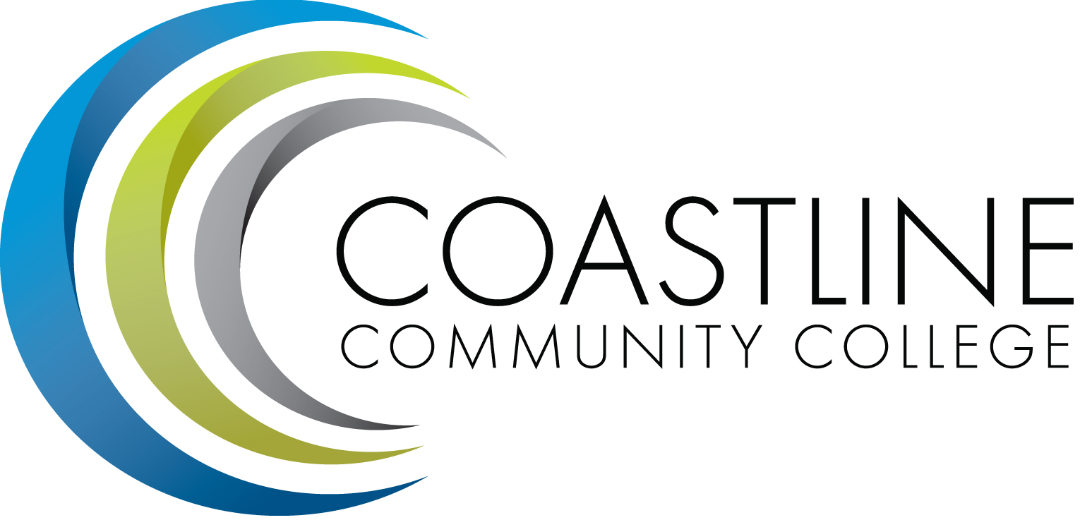

College Professional Development & Leadership Committee Agenda
2/07/2017
3:00 pm to 5:00 pm
College Center, Distance Learning Conference Room

Committee Mandate: To promote, coordinate, recommend, and support the creation and delivery of professional development and leadership programs that increase the effectiveness of our institution and the satisfaction of our employees.
- CALL TO ORDER
  - Roll Call

Present | Members
 | Bob Nash, Co-chair, Associate Dean, Distance Learning & Prof. Development
 | Cheryl Chapman, Co-chair, Academic Senate Representative
 | Mitchell Alves, Faculty Success Center Coordinator
 | Judy Garvey, MECTBD Administrator Representative
 | Elaine Hill, Classified Senate Representative
 | Ken Leighton, Academic Senate Representative
 | Dorothy McCollom, Classified Senate Representative & Committee Support
ABS | Renate Akins, Director of HR
 | Araba Mensah, Classified Senate Representative
 | Randall Warwick, Academic Senate Representative

  - Welcome
  - Adoption of Agenda
  - Approval of Minutes: 12/06/2016

- SPECIAL REPORTS & UPDATES
  - None

- ACTION ITEMS
  - Nate to send Dorothy Kognito Link to post
  - Bob & Cheryl to work on Training Needs Survey

- STANDING REPORTS
  - None

- DISCUSSION ITEMS
  - All-College Survey Results
  - ServiceSkills.com Online Learning
  - Nate Harrison’s Request ($500) for Vet Net Ally Event
  - Daniel Pittaway’s Request ($1,500) for Mini-Workshop on “Growth Mindset and Habits of Mind”
  - Kien Tran’s (Embedded Tutor) Request ($1,500) for Innovation & Bright Ideas Grant on “Coastline Transfer Accessibility & Awareness Project”

- ANNOUNCEMENTS (1-2 minutes per)
  - Next Meeting, March 7, 2017 at 3:00 pm

- ADJOURNMENT

